
ATTRIBUTES AND TRIAL OUTCOMES

ArcAngel is a secure, adjustable, multi-functional neonatal and pediatric endotracheal tube holder that can also secure a feeding and/or gastric suction tube. It is secured to the patient’s cheeks by a proprietary, skin safe long-lasting adhesive.
KEY FEATURES AND BENEFITS:
- Ability to adjust ETT and feeding/gastric suction tubes independently of each other.
- Standardizing ETT securement promotes safety and decreases unplanned ETT extubation from various taping methods.
- All tubes can be secured nasally, orally or a combination of the two.
- 0.25cm hash marks on the holder make adjustments simple, safe, and precise, requiring only one clinician and seconds for adjustments.
- Eliminates tape on baby’s face for better visibility, increasing parental satisfaction.
- Decreased risk of skin damage due to tape irritation and repeated cleaning/reapplication.
- Cheek pads can be wiped clean while remaining on patient’s and are fully adjustable for a custom fit.
- The ArcAngel is easily removable in emergency situations without the need to remove cheek pads.
- Non-allergenic and latex-free.
- MRI safe and metal-free.
- Cheek pads may remain on patient’s face during CPAP/NC trial. If the patient requires reintubation, you can use the same ArcAngel and reinsert into existing cheek pads.
- Increases staff satisfaction as time can be spent on other care tasks.
- Cheek pads are replaceable if needed.
COST SAVINGS:
- ***WE HAVE NOT HAD ANY PATIENT SELF-EXTUBATIONS DURING PATIENT TRIALS DUE TO ETT OR NGT DISLODGEMENT. ***
- Typically, endotracheal securement devices or tape/plasters last 12-36 hours before needing replacement.
- The need for replacement could be due to the following factors: oral secretions loosening and/or soiling the tape, emesis, patient movement, adhesive failure after exposure to heat and humidity.
- Clinical trials have proven that ArcAngel cheek pad adhesive can last upwards of 12+days, despite heat and humidity.
- Trial results have shown that one ArcAngel is equivalent to 5 or more alternate devices.
- Only one clinician is needed for tube adjustments.
- ETT security prevents increased length of stay and prolonged mechanical ventilation and decreases chances of other critical medical issues. *See article excerpts below
- Decreased need for x-rays as trials have proven that once secured in ArcAngel, tubes do not migrate.
- Eliminates patient radiology exposure.
- Eliminates radiology and neonatology resources as less x-rays are required to verify and maintain proper tube position.

SELECT PATIENT TRIAL INFORMATION:

PATIENT A:
GESTATION: 25 2/7 28 3/7 WEIGHT: 730 GM 813 GM HEAD CIRCUMFERENCE: 22.5CM
SIZE OF AA: 1 SIZE OF CHEEK PADS: SMALL BRAND ETT: SHILEY
VENTILATION: HFOV TEMPERATURE OF ISOLETTE: 36.5C HUMIDITY: 0
DAY 1 OF TRIAL ↓:
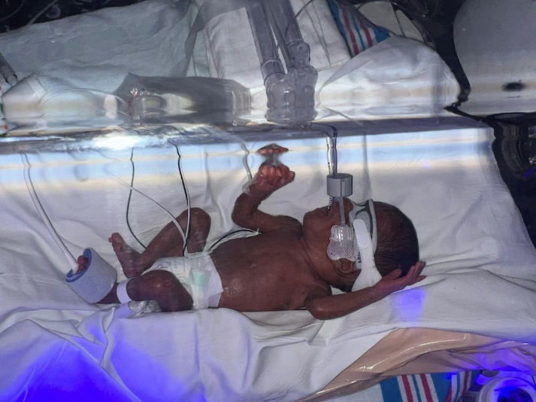
DAY 9 OF TRIAL↓: PADS STILL COMPLETELY INTACT. ISOLETTE CURRENT TEMPERATURE 30.6C
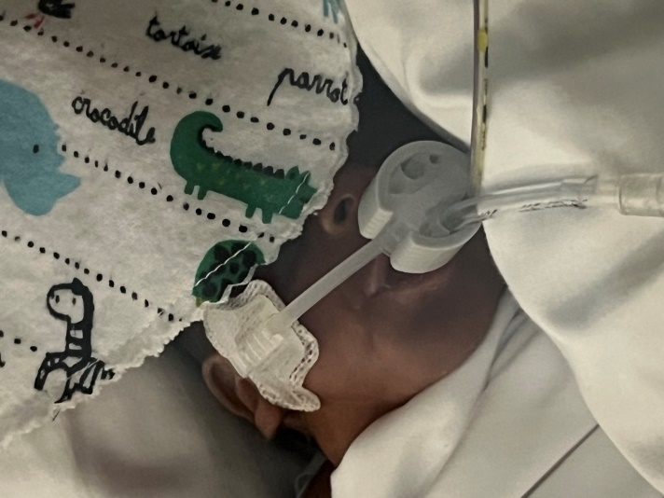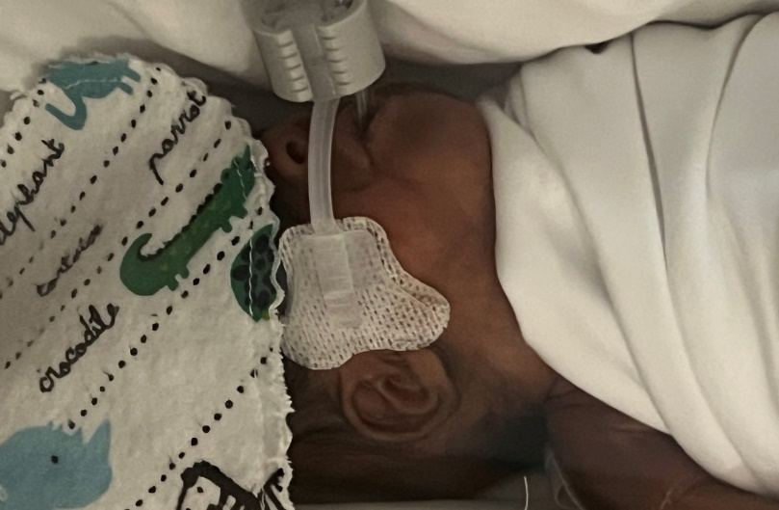

THIS PATIENT WAS ON THE VENTILATOR FOR A TOTAL OF 23 DAYS. HE UTILIZED 1 ARCANGEL AND 1 ADDITIONAL SET OF CHEEK PADS DURING THAT TIME. THIS PATIENT COULD HAVE USED UP TO 15 OTHER ENDOTRACHEAL TUBE SECUREMENT DEVICES AND BEEN RE-TAPED 15 TIMES DURING HIS TIME ON THE VENTILATOR. ONCE HIS TUBES WERE INSERTED INTO ARCANGEL THE STAFF NEVER NEEDED TO ADJUST THEM.

PATIENT B:
GESTATION: 25 2/7 26 2/7 WEIGHT: 750 GM 850 GM HEAD CIRCUMFERENCE: 22.5CM
SIZE OF AA: 0 SIZE OF CHEEK PADS: SMALL BRAND ETT: SHILEY
VENTILATION: SIMV TEMPERATURE OF ISOLETTE: 34C HUMIDITY: 80%
INFANT WAS INTUBATED AND SECURED WITH ARC ANGEL FOR 7 DAYS UNTIL HE WAS ELECTIVELY EXTUBATED TO CPAP. CHEEK PADS LEFT ON FACE IN CASE OF RESPIRATORY FAILURE. 24 HOURS LATER, CHEEK PADS (STILL ADHERED SECURELY) WERE REMOVED USING NURSE ANGELE’S WIPES. SKIN UNDERNEATH WAS FLAWLESS. INFANT THEN PLACED ON HIGH FLOW NASAL CANNULA. NURSE COMMENTED TO ME THAT THE CHEEK PADS WERE REALLY ADHERED WELL BUT NURSE ANGELE’S WIPES REMOVED THEM BEAUTIFULLY!

PATIENT C:
GESTATION: NEWBORN 23 4/7 WEIGHT: 630 GM HEAD CIRCUMFERENCE: 20.6CM
SIZE OF AA: 0 SIZE OF CHEEK PADS: SMALL BRAND ETT: PORTEX
VENTILATION: CONVENTIONAL & HFOV TEMPERATURE OF ISOLETTE: 36C HUMIDITY: 90%
**THIS INFANT WAS JUST BORN VIA EMERGENCY CAESAREAN SECTION AND WAS INTUBATED IN THE DELIVERY ROOM. THE PATIENT EXTUBATED 4X IN THE FIRST 45 MINUTES OF LIFE. THE PATIENT UTILIZED 4 NEOBARS IN 45 MINUTES. PATIENT WAS INTUBATED FOR A 5TH TIME, ARCANGEL WAS UTILIZED AND PATIENT NEVER EXPERIENCED ANOTHER EXTUBATION. **

SELECT CLINICIAN TRIAL FEEDBACK:
- BEDSIDE NURSE: “PROVIDES MORE STABILITY TO AIRWAY. LESS PLAY ON CHEEKS AND MORE STABLE WITH ARC ANGEL THAN NEOBAR. NUMBERS ARE EASIER TO VISUALIZE THAN WITH TAPE AND NEOBAR.”
- BEDSIDE NURSE: “I AM THOROUGHLY IMPRESSED WITH ARCANGEL. IT IS VERY USER FRIENDLY AND MUCH BETTER FOR OUR BABIES. THE PADS ARE MUCH BETTER THAN OUR CURRENT PRODUCT. THEY STICK MUCH BETTER! THE PRODUCT MATERIAL STAYS CLEAN, WHICH IN MY OPINION IS A HUGE PLUS!!! I LOVE HOW THE BAR CAN MOVE IN AND/OR OUT TO ALLOW FOR GROWTH. THE ETT IS VERY SECURE AND THE NUMBERS ARE EASILY READABLE. IT ALSO ALLOWS FOR EASY TUBE ADJUSTMENTS IF NEEDED. IN MY OPINION, THIS PRODUCT IS VERY SAFE AND EFFECTIVE. 10/10”
- NEONATOLOGIST: “I THINK IT IS A GREAT PRODUCT THAT SECURES TUBES AND CATHETERS MUCH BETTER THAN ALTERNATIVE STRATEGIES.”

RESEARCH:
MANIPULATION OF THE ENDOTRACHEAL TUBE DURING RESECURING CAN CAUSE AN INSTABILITY IN VITAL SIGNS. OFTEN THE PATIENT’S HEART RATE AND OXYGENATION DECREASE, ALONG WITH AN INCREASE IN PAIN, ANXIETY AND AGITATION. A DECREASE IN HEART RATE AND OXYGENATION CAN LEAD TO OTHER CRITICAL MEDICAL ISSUES, SUCH AS SPONTANEOUS INTESTINAL PERFORATION, ACUTE KIDKEY INJURY, INTRAVENTRICULAR HEMORRHAGE DUE TO POSITIVE PRESSURE VENTILATION FOR OXYGENATION RECOVERY AND RETINOPATHY FROM INCREASED OXYGEN REQUIREMENTS, AMONG OTHERS.
INFANT SELF-EXTUBATION CAN LEAD TO THE SAME CRITICAL MEDICAL COMPLICATIONS AND EXTENDED TIME ON THE VENTILATOR AND EXTENDED LENGTH OF STAYS.

L. Dupree Hatch, Theresa A. Scott, James C. Slaughter, Meng Xu, Andrew H. Smith, Ann R. Stark, Stephen W. Patrick, E. Wesley Ely; Outcomes, Resource Use, and Financial Costs of Unplanned Extubations in Preterm Infants. Pediatrics June 2020; 145 (6): e20192819. 10.1542/peds.2019-2819
- “Unplanned extubations (UEs) are the most common adverse event during mechanical ventilation (MV) in the NICU.”
- “We have shown that UEs (unplanned extubations) in preterm infants are associated with significantly poorer in-hospital outcomes and increased financial costs, in addition to their well-known acute harmful effects. In our primary cohort, exposure to ≥1 UEs was associated with a nearly 1-week increase in the duration of postmatching MV (mechanical ventilation), a 10-day increase in LOS (length of stay), and a nearly $50,000 increase in total hospital costs. These effects remained significant even after adjusting for differences in clinical characteristics between the groups.”
- “In addition to prolonged duration of MV, UEs were associated with worsened respiratory outcomes, including supplemental oxygen use at 36 weeks’ PMA and total days of in-hospital supplemental oxygen use.”
- “Most infants who were reintubated within 3 days of their primary UE (32 out of 49, 65%) had increased respiratory support after reintubation as evidenced by a higher mean airway pressure or inspired oxygen concentration in the 24 hours after reintubation compared with those values on the day of UE.”
- “Modest investments by hospital systems in quality improvement programs to decrease UEs in the NICU may yield signiﬁcant cost savings while improving overall quality of care.”

John P. Galiote, Michelande Ridoré, Jessica Carman, Lisa Zell, Karen Brant, Cheyenne Gayle, Billie L. Short, Darren Klugman, Lamia Soghier; Reduction in Unintended Extubations in a Level IV Neonatal Intensive Care Unit. Pediatrics May 2019; 143 (5): e20180897. 10.1542/peds.2018-0897
- “UEs can lead to airway trauma, intraventricular hemorrhage, and cardiovascular collapse.”
- “Initiating and maintaining a culture of safety in the NICU is essential for the treatment of newborns who are critically ill. The use of invasive mechanical ventilation via endotracheal tube (ETT) remains a key component of neonatal care.”
- “Reducing UE can be successfully accomplished in a NICU setting to achieve levels below national benchmarks through standardization and mitigation interventions. Continued vigilance is imperative to sustain reduction, identify special causes, and reinforce measures with staff.”

RESOURCES:

